**LAB ASSIGNMENT – 8**

**DECISION MAKING CLASSIFIERS MEASURES**

**NAME : PRATHAPANI SATWIKA**

**REG.NO : 20BCD7160**

Develop python functions for the following Decision Tree measures, Information Gain, Gain Ratio, and Gini Index, and attribute types, Categorical and Numerical.

Input: A data frame consists of Attribute and its Class Label

Output: Splitting Criteria, Data Partitions after splitting, and corresponding calculated measure values.

Utilize these functions to find out best splitting criteria for the following datasets: tennis.csv and iris.csv

**CODE & OUTPUT :**

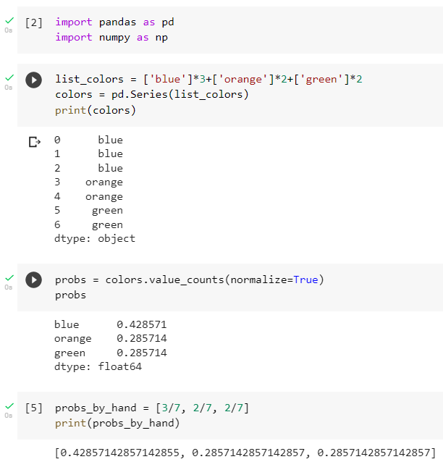

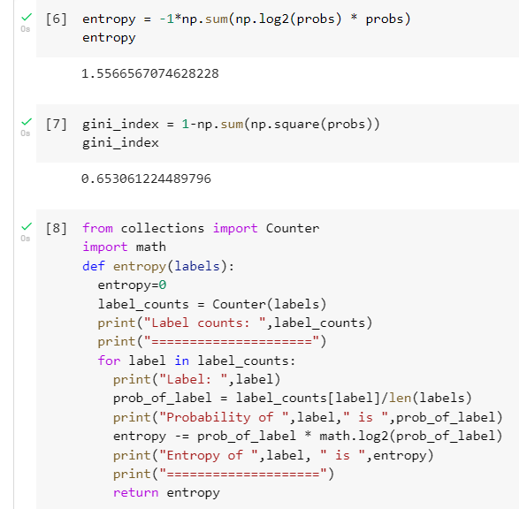

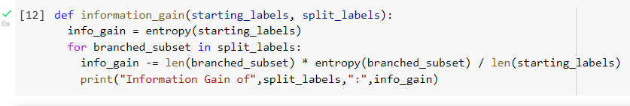



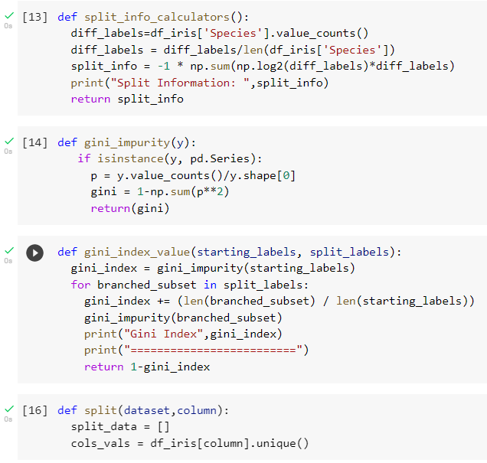



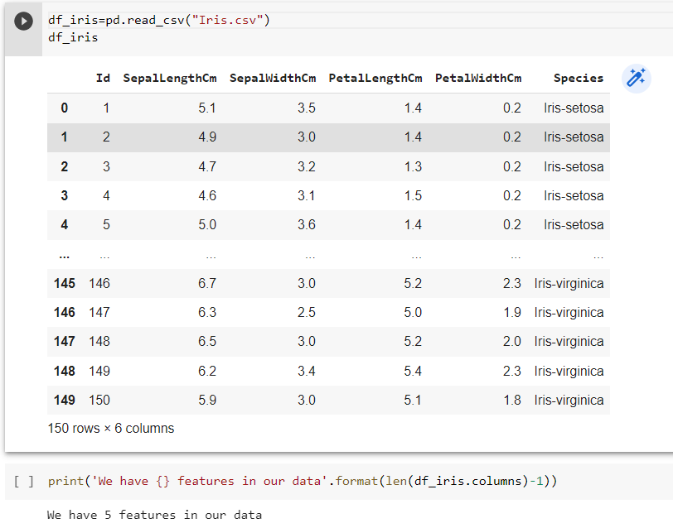

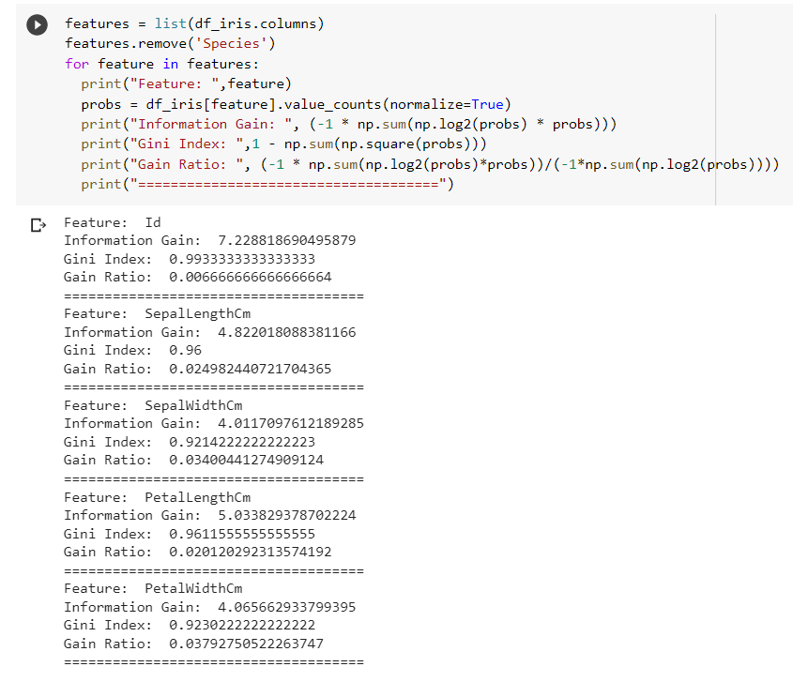

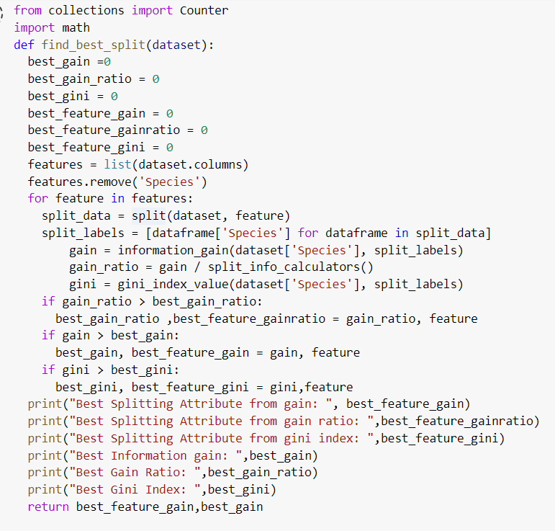

Entropy of *,label, * is 0.0

================

Label counts: Counter({'Iris-virginica': 1})

===================

Label: Iris-virginica

Probability of Iris-virginica is 1.0

Entropy of *,label, * is 0.0

================

Label counts: Counter({'Iris-virginica': 1})

===================

Label: Iris-virginica

Probability of Iris-virginica is 1.0

Entropy of *,label, * is 0.0

================

Label counts: Counter({'Iris-virginica': 1})

===================

Label: Iris-virginica

Probability of Iris-virginica is 1.0

Entropy of *,label, * is 0.0

================

Label counts: Counter({'Iris-virginica': 1})

===================

Label: Iris-virginica

Probability of Iris-virginica is 1.0

Entropy of *,label, * is 0.0

================

Label counts: Counter({'Iris-virginica': 1})

===================

Label: Iris-virginica

Probability of Iris-virginica is 1.0

Entropy of *,label, * is 0.0

================

Label counts: Counter({'Iris-virginica': 1})

===================

Label: Iris-virginica

Probability of Iris-virginica is 1.0

Label counts: Counter({'Iris virginica': 1})

===================

Label: Iris-virginica

Probability of Iris

Entropy of *,label, * is 0.0

================

Label counts: Counter({'Iris-virginica': 1})

===================

Label: Iris-virginica

Probability of Iris-virginica is 1.0 Entropy of *,label, * is 0.0 ================

Label counts: Counter({'Iris

=================== Label: Iris

Probability of Iris

Entropy of *,label, * is 0.0

================

Label counts: Counter({'Iris-virginica': 1})

===================

Label: Iris-virginica

Label counts: Counter({'Iris-

===================

Label: Iris-virginica

Probability of Iris-

Entropy of *,label, * is 0.0

================

Label counts: Counter({'Iris-

===================

Label: Iris-virginica

Probability of Iris-virginica is 1.0

Entropy of *,label, * is 0.0

================

Label counts: Counter({'Iris-virginica': 1})

===================

Label: Iris-virginica

Probability of Iris-virginica is 1.0

Entropy of *,label, * is 0.0

================

Label counts: Counter({'Iris-virginica': 1})

===================

Label: Iris-virginica

Probability of Iris-virginica is 1.0

Entropy of *,label, * is 0.0

================

Label counts: Counter({'Iris-virginica': 1})

===================

Label: Iris-virginica

Probability of Iris-virginica is 1.0

Entropy of *,label, * is 0.0

================

Label counts: Counter({'Iris-virginica': 1})

===================

Label: Iris-virginica

Probability of Iris-virginica is 1.0



